**Hands-on Exercise Assignment #6**

Name: ___________________________

**Learning objective**: Examine how to add image resources to a JavaScript animation/game. In this exercise students learn how to trap mouse movements and use this to activate a paddle.

To start, download and save in appropriate locations the resources for this exercise (html and images files) If you need a JavaScript reference, here is one by W3Schools: <https://www.w3schools.com/js/default.asp>

**PART I: Basic concepts: adding image resources to a JavaScript animation/game.**

Use the following code segment to answer the following questions.

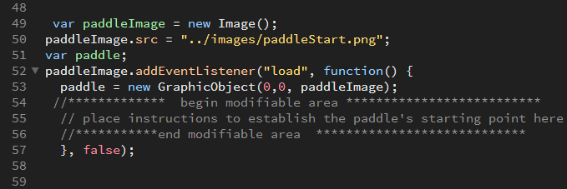

1. What is the purpose of the instruction at line 49?   
     
   ___Creates an image object which will be used to access an image file ______________  
     
   _______________________________________________________________________
2. Identify where the image file is stored in relation to the .html file, based on the file path in line 50.  
   _the file is stored in a folder called images which is in the folder that contains the HTML   
     
   file ____________________________________________________________________
3. What is the purpose of line 51?  
   _____this line declares the paddle object so that it is accessible throughout the program.   
     
   _______________________________________________________________________  
     
   ________________________________________________________________________
4. What is the purpose of the event listener identified in line 52?   
     
   ___This allows specified code to wait for execution until after the image file has   
     
   completed download. _______________________________________________
5. Explain line 53.  
   The paddle object is created using the GraphicObject class, passing the values 0,0,image   
     
   to the properties of the paddle object, x,y, and image respectively.________________  
     
   _________________________________________________________________

**PART II: provide starting position for paddle object and move paddle with mouse.**

Update starting position of paddle.

1. Where would you place instructions (line number range) to establish the paddle object’s starting position?  
   ____________________between lines 54 and 56________
2. What instructions will you use to establish the paddle object’s starting position at the center of the canvas vertically and on the right edge of the canvas? Show these instructions below:  
     
   __________ paddle.x = canvas.width - paddle.width;_________________________  
     
   ___________ paddle.y = canvas.height/2 - paddle.height/2;____________________  
   test your program to make sure your paddle is located at the desired location. You may have to move your cursor to see the paddle.
3. Inspect the HTML definition for the canvas (line 14). What is the function that responds to mouse motion?  
   ____________________ mouseMove(event)_________________________________
4. Make sure the event listening/trapping works by removing the // in front of the console.log instruction. Check the browser console to ensure the message is appearing when the mouse moves over the canvas. Once you ensure the event listening mechanism works, you may replace the //.
5. Now make your paddle follow the y-coordinate of the mouse so that it moves up and down (but not side to side) with the mouse. Recall the event listening mechanism for mouse motion is as follows:  
   Your instructions to move the paddle should be placed inside the function, identified above. Show all your instructions below: (make sure you test your program)  
     
   __________ paddle.y = event.clientY;__________________________________  
   ______________________________________________________________________