Quiz for Assignment 02

Name:___________________

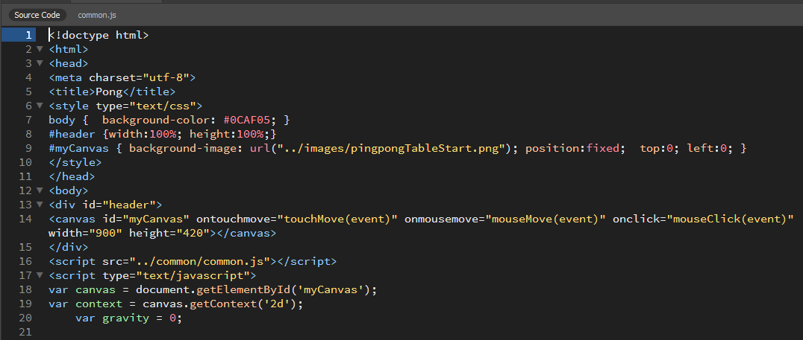

Answer the following questions based on the above portion of HTML and JavaScript, when appropriate.

1. Describe where the image file, pingpongTableStart.png, is in relation to the HTML file that is referencing it.
2. How can one distinguish HTML instructions from JavaScript instructions?
3. At which line number does the JavaScript begin? _________
4. What player/user actions can one identify in JavaScript, based on the HTML provided.
5. Describe all the elements that are necessary for JavaScript to interact with the HTML canvas? Make sure you identify the instruction that makes this connection and what must be present in the HTML for this to function correctly.